Security group creation:

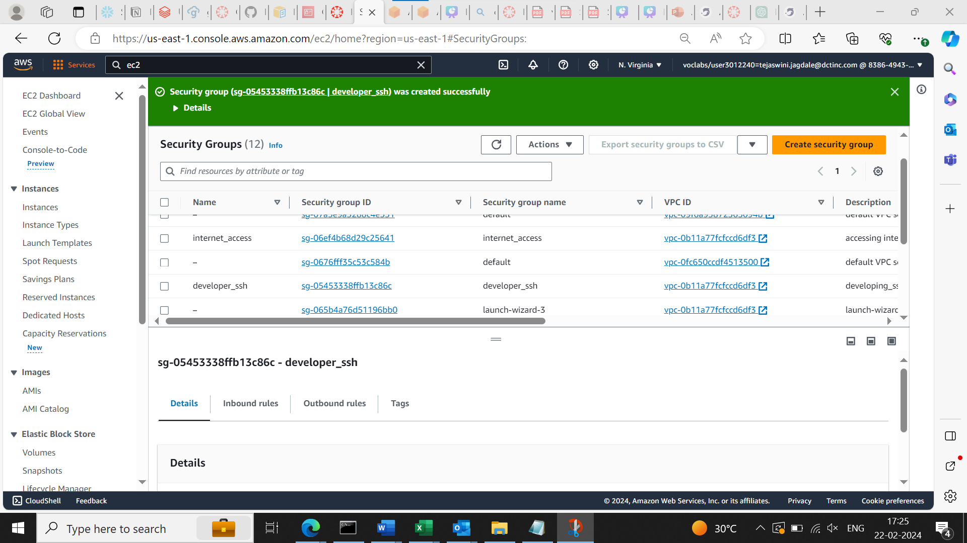

Instance Creation:

 We are using an Apache server in this tutorial so for that we need to install httpd to run apache server. httpd is Produced by Apache Foundation and it is a piece of software that listens for network requests and responds to them

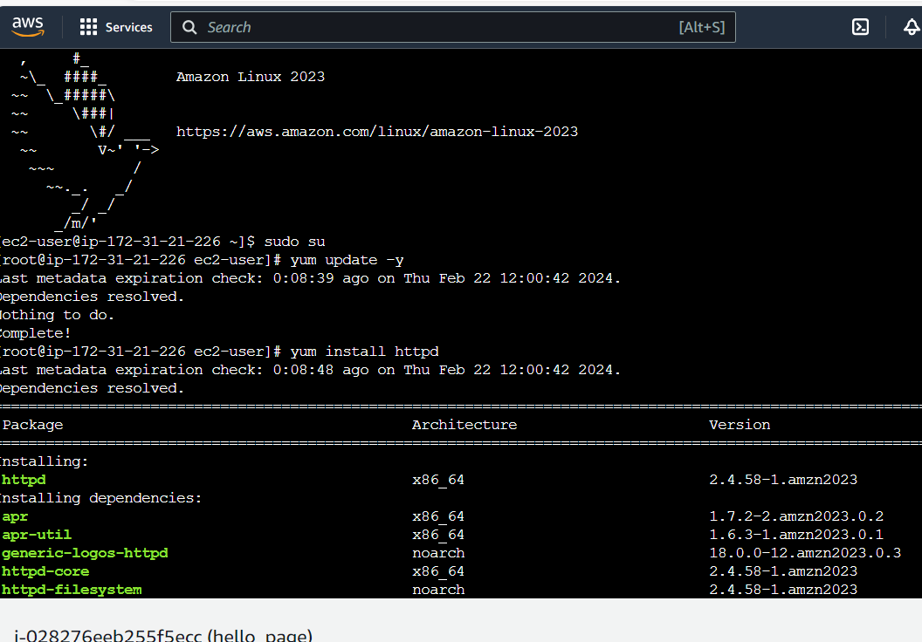

Start and enable the httpd



